1. Grade Checker

Take a score as input and print the grade based on the following:

90+ : "A"

80-89 : "B"

70-79 : "C"

60-69 : "D"

Below 60 : "F"

here we used a basic if else statement to carry out marks and all.

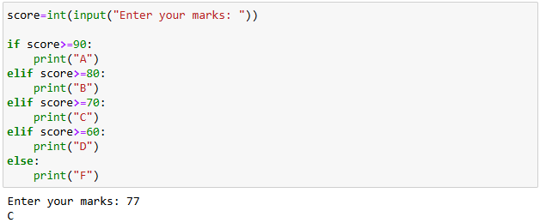

2 Student Grades

Create a dictionary where the keys are student names and the values are their grades. Allow the user to:

Add a new student and grade.

Update an existing student’s grade.

Print all student grades.

Used dictionary and basic operations. Using if else:

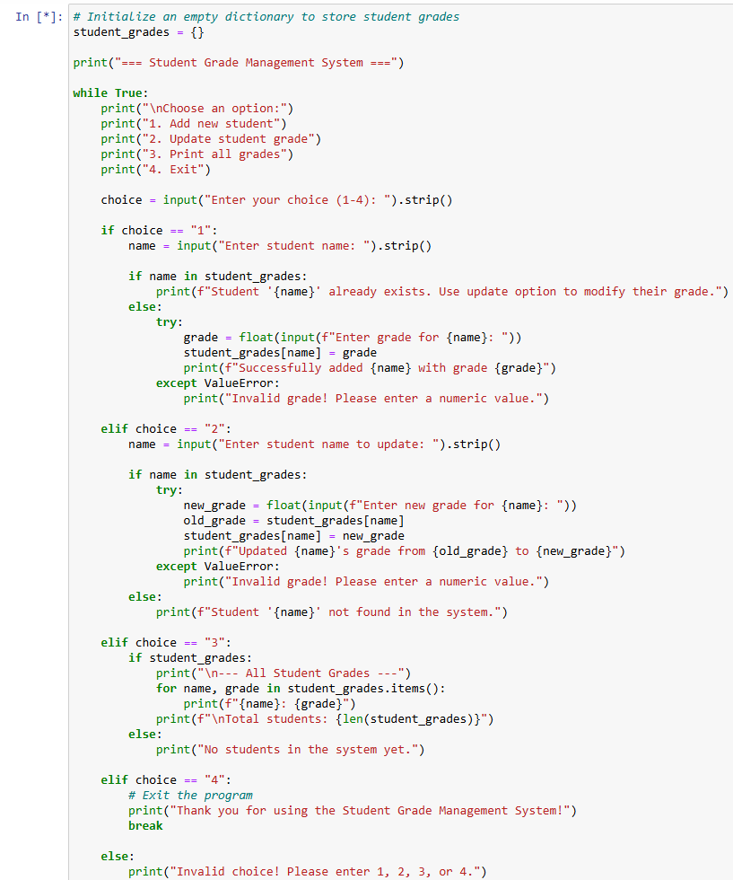

student_grades = {}

print("=== Student Grade Management System ===")

while True:

print("\nChoose an option:")

print("1. Add new student")

print("2. Update student grade")

print("3. Print all grades")

print("4. Exit")

choice = input("Enter your choice (1-4): ").strip()

if choice == "1":

name = input("Enter student name: ").strip()

if name in student_grades:

print(f"Student '{name}' already exists. Use update option to modify their grade.")

else:

try:

grade = float(input(f"Enter grade for {name}: "))

student_grades[name] = grade

print(f"Successfully added {name} with grade {grade}")

except ValueError:

print("Invalid grade! Please enter a numeric value.")

elif choice == "2":

name = input("Enter student name to update: ").strip()

if name in student_grades:

try:

new_grade = float(input(f"Enter new grade for {name}: "))

old_grade = student_grades[name]

student_grades[name] = new_grade

print(f"Updated {name}'s grade from {old_grade} to {new_grade}")

except ValueError:

print("Invalid grade! Please enter a numeric value.")

else:

print(f"Student '{name}' not found in the system.")

elif choice == "3":

if student_grades:

print("\n--- All Student Grades ---")

for name, grade in student_grades.items():

print(f"{name}: {grade}")

print(f"\nTotal students: {len(student_grades)}")

else:

print("No students in the system yet.")

elif choice == "4":

# Exit the program

print("Thank you for using the Student Grade Management System!")

break

else:

print("Invalid choice! Please enter 1, 2, 3, or 4.")

3.Write to a File

Write a program to create a text file and write some content to it.

Using file functions like write and open.

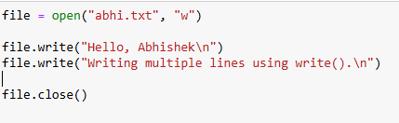

4. Read from a File

We used open in read mode and file.read to read and print to display.

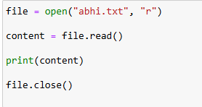

**Submission Guidelines -:** Attach Screenshots or command along with explanation and submit in doc(google doc or microsoft doc) format or share github link